

University of Sadat City
Faculty of Computers and Artificial Intelligence

Learnix E-Learning Platform

Team Members
1- Abdulrahman Amr Abdelnaby Meslhy
2- Mohamed Yaser Salah Elnagar
3- Mohamed Atef Mohamed Abu-Yousef
4- Abdelaziz Ahmed Saad Aresha
5- Ahmed Moustafa Elbhery

Under the supervision of:
Dr. Heba Askr Eng. Yasmeen Samir

Table of Contents

Section | Topic | Page
1 | Introduction | 3
2 | Project Overview | 4
3 | Technologies Used | 5
4 | HTML & CSS (Frontend) | 8
5 | Database Design with SQL | 9
6 | C# and OOP Concepts | 10
7 | LINQ Queries | 11
8 | ASP.NET MVC Architecture | 12
9 | CRUD Operations | 13
10 | Authentication & Authorization | 15
11 | Learnix Features Implementation | 16
12 | System Workflow | 18
13 | Challenges and Solutions | 20
14 | Conclusion | 22

1.Introduction
This documentation provides a comprehensive overview of the Learnix E-Learning Platform, developed as our graduation project for the Full Stack Development course. The document explains all the technologies and concepts we applied throughout the development process, including HTML, CSS, SQL, C#, Object-Oriented Programming (OOP), LINQ, and ASP.NET MVC.
Learnix is designed to solve the problem of finding organized, high-quality online learning content. The platform connects students with instructors, providing a structured environment for online education with features like course enrollment, lesson management, and progress tracking.
This documentation serves as:
- Evidence of our understanding of full stack development concepts
- A technical guide explaining how each technology was implemented
- A reference for future enhancements and maintenance
- A submission for our course graduation requirement

2.Project Overview
Learnix is an online learning platform built to solve the problem of finding organized,
high-quality educational content. Many existing platforms are expensive or complicated. Learnix is simple, structured, and scalable.

2.1 Our Main Objectives:
- Allow Instructors to create and manage their courses.
- Allow Students to browse, enroll, and track their progress in courses.
- Provide an Admin to manage users and the platform.
- Implement secure login and signup.
- Simulate real-world business logic like sharing course revenue
(95% to instructor, 5% to admin).

2.2 The three main users are:
- Student: Browses and enrolls in courses.
- Instructor: Creates courses, uploads lessons, and sees enrolled students.
- Admin: Manages the entire platform and approves new instructors.

3. Technologies Used

Learnix is built using a complete full stack technology set, from frontend to database.

3.1 Frontend Technologies
Technology | Purpose
HTML5 | Structure web pages and content
CSS3 | Style and layout web pages
Razor Views | Combine C# code with HTML in ASP.NET

3.2 Backend Technologies
Technology | Purpose
C# | Main programming language for application logic
ASP.NET MVC | Web application framework (Model-View-Controller)
Entity Framework Core | Object-Relational Mapping (ORM) for database access
LINQ | Language Integrated Query for data manipulation
ASP.NET Identity | Authentication and authorization system

3.3 Database
Technology | Purpose
Microsoft SQL Server | Database management system
SQL | Query language for database operations

3.4 Development Tools
Tool | Purpose
Visual Studio 2022 | Integrated Development Environment (IDE)
Git | Version control system
GitHub | Code repository and collaboration platform

3.5 Technology Stack Diagram
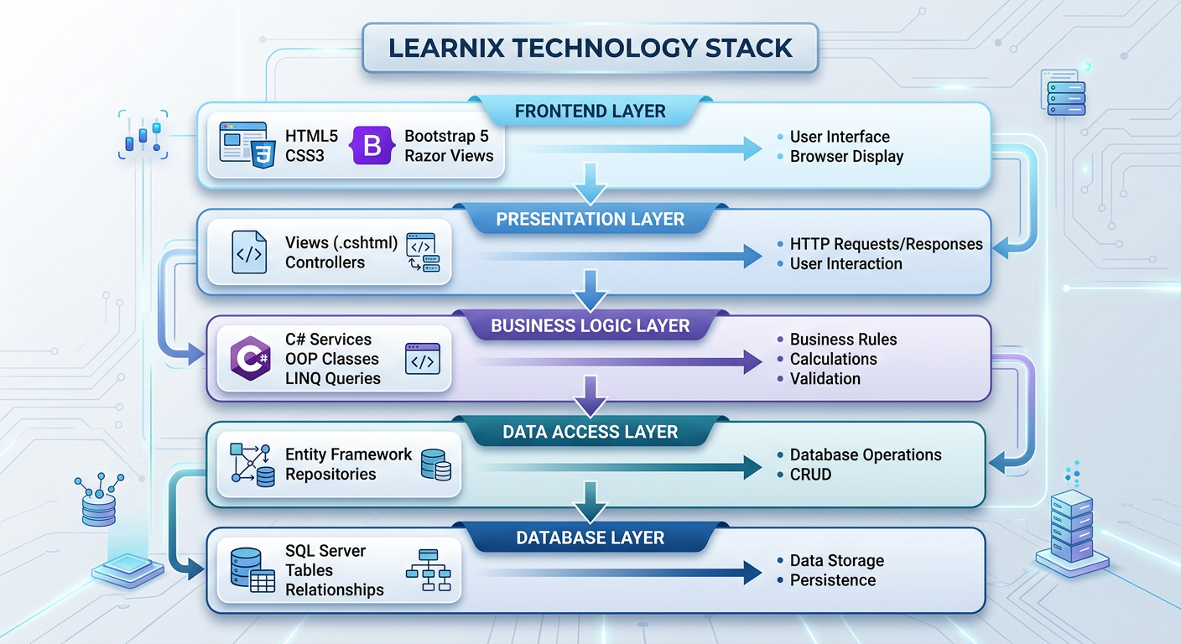

4. HTML & CSS (Frontend Development)

4.1 What is HTML?
HTML (HyperText Markup Language) is the standard markup language for creating web pages. It describes the structure of web pages using markup elements or tags.
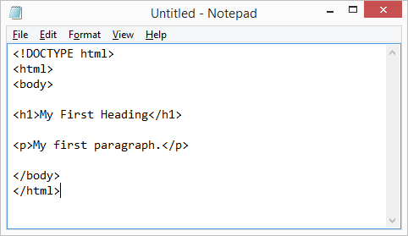

4.2 What is CSS?
CSS (Cascading Style Sheets) is a stylesheet language used to describe the presentation of HTML documents. It controls colors, fonts, layouts, and responsive design.

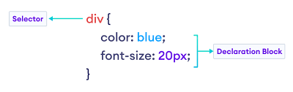

5. Database Design with SQL

5.1 What is SQL?
SQL (Structured Query Language) is a programming language designed for managing data in relational databases. It allows us to create, read, update, and delete data.

5.2 Database Design Principles Applied
In Learnix, we applied these database design principles:
- Normalization: Eliminating redundant data
- Relationships: Defining how tables connect
- Primary Keys: Unique identifiers for each record
- Foreign Keys: Creating relationships between tables
- Indexes: Improving query performance

5.3 Table Structures
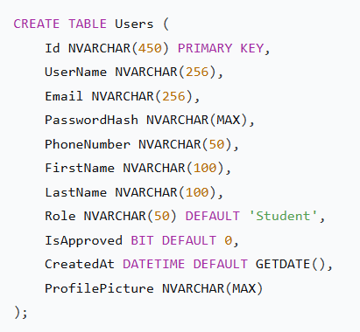

6. C# and Object-Oriented Programming (OOP)

6.1 What is C#?
C# is a modern, object-oriented programming language developed by Microsoft. It is the primary language we used to build the backend logic of Learnix.

6.2 Object-Oriented Programming (OOP)
OOP is a programming paradigm based on the concept of "objects" that contain data and methods. The four main pillars of OOP are:
- Encapsulation: Bundling data and methods within a class
- Inheritance: Creating new classes based on existing ones
- Polymorphism: Using a single interface to represent different types
- Abstraction: Hiding complex implementation details

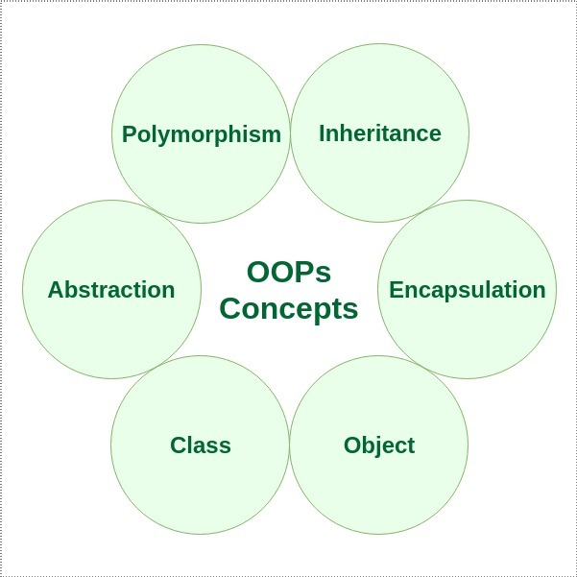

7. LINQ (Language Integrated Query)

7.1 What is LINQ?
LINQ is a set of features in C# that allows you to write SQL-like queries directly in C# code. It provides a consistent way to query data from different sources (databases, collections, XML).

7.2 Why LINQ?
- Type safety: Errors are caught at compile time
- IntelliSense support: Auto-completion in Visual Studio
- Consistency: Same syntax for different data sources
- Readability: Code is easier to understand

7.3 LINQ Query Syntax Examples
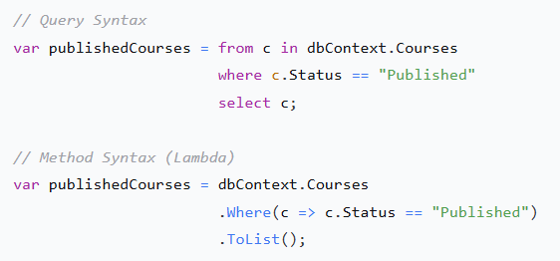

8. ASP.NET MVC Architecture

8.1 What is MVC?
MVC (Model-View-Controller) is an architectural pattern that separates an application into three main components:
- Model: Represents the data and business logic
- View: Presents the data to the user (UI)
- Controller: Handles user input and coordinates between Model and View

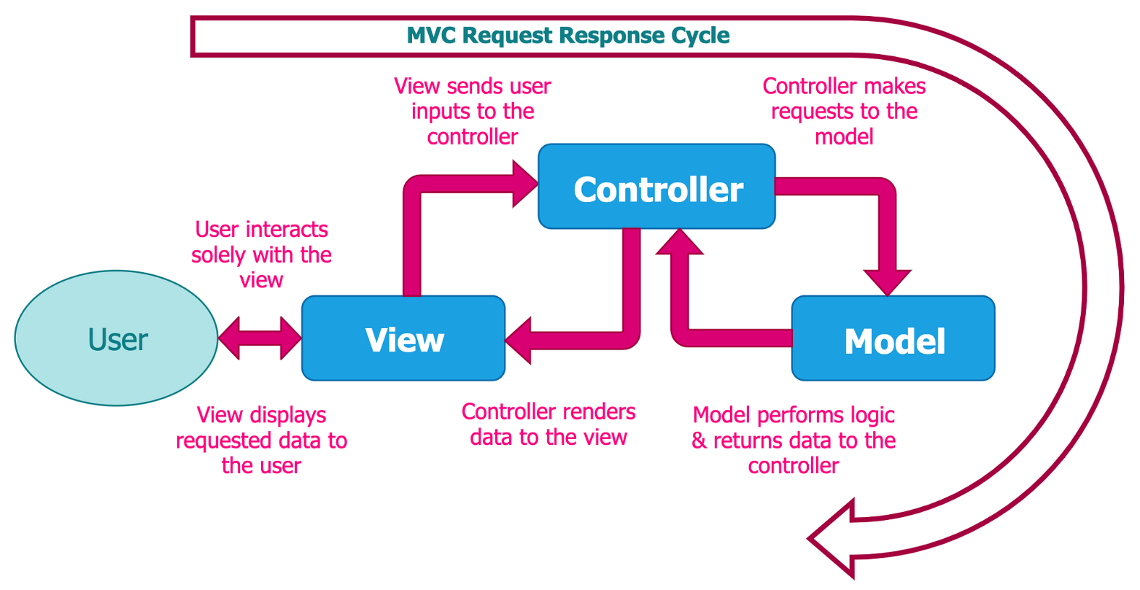

9. CRUD Operations
